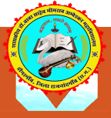

Govt. Dr. Baba Saheb Bhimrao Ambedkar PG College Dongargaon,Distt.-Rajnandgaon (C.G.), Pin - 491661SESSION 2023-24AQAR 2023-24

**1.1.3 - Teachers of the Institution participate**